Three days, three ways is no longer the preparedness message
Posted by Washington Emergency Management Division
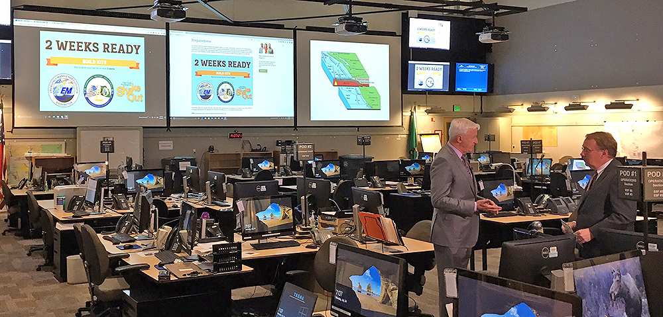

KING 5’s Glenn Farley and a news crew spent the morning and afternoon in our state Emergency Operations Center on Monday, July 24, as the Seattle-based television station focused its news coverage entirely on emergency preparedness.
The focus was on getting residents “2 Weeks Ready” for a potential devastating earthquake, a theme the Washington Military Department has been promoting since last summer’s Cascadia Rising emergency exercise focused on a 9.0 earthquake and tsunami. The series came about after the television station moved to its new location across from Safeco Field in Seattle and station managers quickly realized their own disaster plans were out of date. For that matter, they also realized that a huge segment of the population is also unprepared.
“We can’t talk enough about emergency preparedness and appreciate the significant amount of time devoted to improving our personal readiness for a catastrophic disaster,” said Washington Emergency Management Director Robert Ezelle, who was interviewed during the broadcasts.
Col. Jeremy Horn of the Washington National Guard was also interviewed several times live in the morning.
So, what can you do now?
- Residents can download a “2 Weeks Ready” brochure at our website mil.wa.gov/preparedness and start shopping.
- We’re co-hosting a business preparedness forum on Aug. 2 in King County. More info here.
- You can register for the Great Washington ShakeOut and start practicing your Drop, Cover & Hold on skills – and make a commitment to improve your emergency kit by the ShakeOut date of Oct. 19.
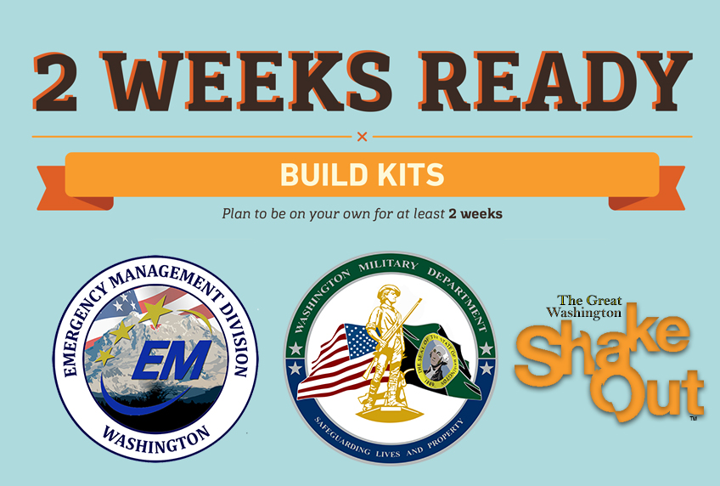
“After a devastating earthquake, our roads will be torn up and there aren’t enough helicopters to get supplies to everywhere,” Ezelle said.
The state will be taking steps following a disaster, teaming with national organizations like FEMA and the Department of Defense, to hopefully get supplies to people who need it – but those supply drops could be many, many days out from the initial earthquake.
“And residents need to be on their own,” Ezelle said. “They need to know that help will come. But you will be on your own for several days. This is a reality check for a lot of people.”
The old “three days, three ways” preparedness messaging just doesn’t work anymore, he said.
- Our earthquake program manager Maximilian Dixon was interviewed about neighborhood preparedness in this piece about planning.
- Residents in apartments can get advice about preparedness in this piece. There’s also a downloadable guide to help apartment dwellers come up with their own plans.
- Ezelle talks about the lessons learned from Cascadia Rising in this piece by Farley.
- Reporter Heather Graf takes our 2 Weeks Ready guide for a spin and proved it’s pretty easy to shop for a preparedness kit.
- Drop, Cover & Hold on Works in this piece.
There’s also lots more about pets and emergency kits at http://www.king5.com/local/disaster and hashtag #AreYouPrepared
And we have you covered with preparedness materials and guides at mil.wa.gov/preparedness
https://mil.wa.gov/blog/news/post/three-days-three-ways-is-no-longer-the-preparedness-message

