Stair Safety
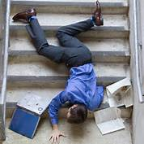
When you hear Slip-Trip-Fall, most people think of that happening on level surfaces. The same thing can happen when you are using stairs. Stairs of all types have been used since ancient times, and because they are inherently hazardous, people have been falling on them, getting hurt or even killed in the process. A very common contributing factor is neglecting to use handrails. The consequences can be quite nasty.
Because stairway accidents can cause severe injury and even death, building codes for stairs and ramps are justifiably very rigorous. Good design can substantially reduce the potential for mis-stepping by providing us with the means to retrieve our balance, but even the best design cannot eliminate falling hazards entirely. The fact is that incidents can be caused by inattention and unsafe behavior.
Review the information below to make sure your stairwells are as safe as possible.

Stair surface
To reduce the risk of slipping on stairs, non-slippery surface on the whole steps or at least on the leading edges is crucial. Such a surface can be made of rubber or metal or painted with special slip-resistant paint. Regular maintenance of the stairs in good repair plus good housekeeping can reduce hazards for tripping.

Stair handrails
The prime function of the handrail is for holding as support while going up or down stairs. You should be able to run your hand smoothly along the entire length without having to adjust your grip. Always leave one hand free to use the handrail, going up or down.

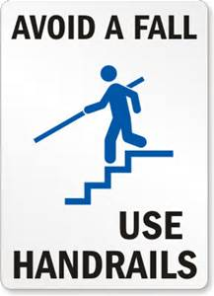
Visibility on stairs
Improving visibility on stairs significantly reduces the risk for common mishaps caused by misjudging distances. Otherwise you can trip on a step or miss it completely. You can catch a heel on the edge of a step. Such mishaps are a routine cause of twisted ankles, sprained knees or more serious injuries incurred by a total fall.
• Use angular lighting and color contrast to improve depth perception.
• Use matte finishes on the treads to avoid glare.
• Avoid patterned carpeting that may visually hide differences in depth.
• If possible, color code the tread edge in yellow or white to differentiate each step.

Work activity
Whenever performing physical work that involves moving up and down stairs, keep the following in mind:
• Use any means to persuade people to grasp the handrail while both ascending and descending stairs.
• Avoid carrying objects with both hands.
• Do not carry bulky objects that block your vision.
- Use the elevator when moving large objects.

Housekeeping
Good housekeeping is also vital to stair safety:
• Nothing should be sticking out the surfaces of stairs, handrails or banisters (like nails or splinters) that could cause a fall.
- Treads should be free from loose objects and carpet or non-skid strips should be firmly in place.
• Spills, wet spots, or any debris should be immediately cleaned up. Broken or malfunctioning lighting should be repaired or replaced.

When using steps outside, you should be even more cautious because of the possibility of them being wet, icy, snowy or even covered with leaves and moss. Since they are exposed to the elements, they are often not in the best condition and require extra care when using them.

Remember that the chances of falling are also increased by illness, fatigue, haste, use of alcohol and drugs, including medications. Studies show that keeping yourself healthy and fit will help prevent falls.

