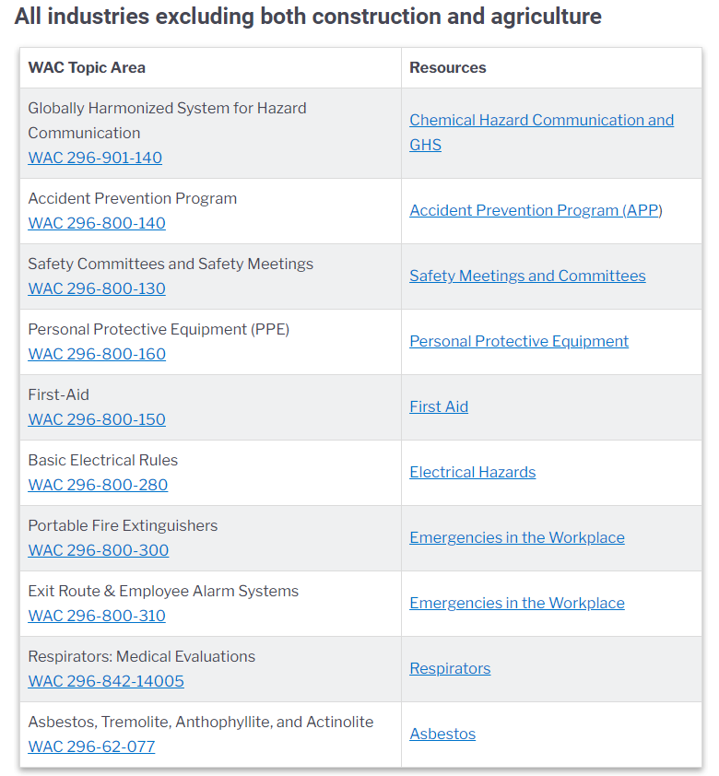

This table shows the most common safety & health rules cited during L&I inspections from Oct. 2019 - Sept. 2020 (Federal Fiscal Year 2019).