Latest Course - RISE UP Warehouse, Inventory, and Logistics

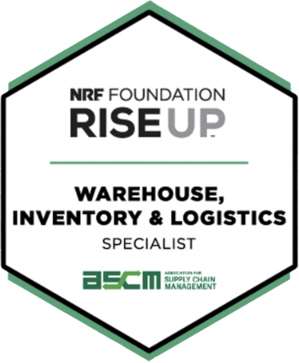
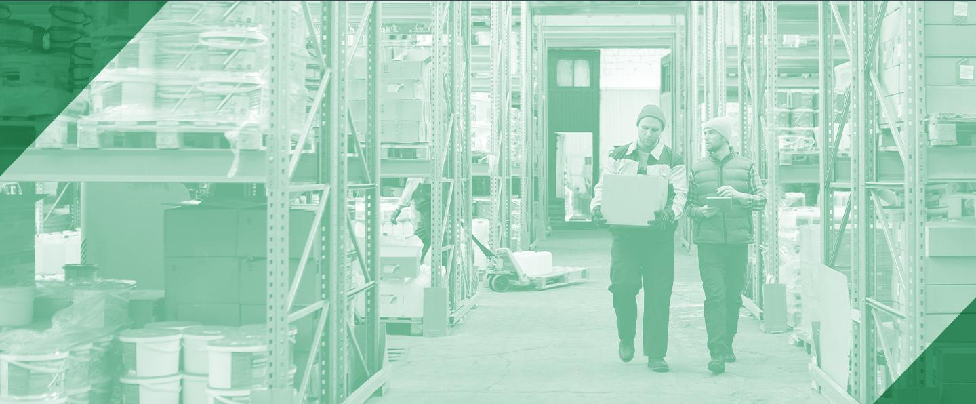

The newest course in the NRF Foundation’s skills training series is the RISE Up Warehouse, Inventory and Logistics credential. The course will help you understand supply chains and develop workplace readiness skills for roles in warehouses, distribution, or fulfillment centers.

Developed in collaboration with the Association for Supply Chain Management Foundation, this course will give you insights into the importance of supply chains and the flow of goods. You will learn how warehouses are designed and operated and help you practice calculating and explaining key performance metrics. You will learn about safety measures, explore critical warehousing roles, and discover how to succeed in this exciting career path.

This online course takes just five to seven hours to complete, and you can use any computer or tablet. You can work at your own pace to complete the training, and you will complete three 16-question quizzes along the way to demonstrate you’ve mastered the content. The dynamic curriculum includes videos and interactive exercises.

Do you have an employee who is showing interest in growth within your company? Are you currently working with internship/apprenticeship programs? NRF Foundation is allowing Washington Retail to offer these classes to our members at a reduced rate.

Please contact Rick Means, 360.200.6454, or Rose Gundersen, 360.200.6452, to answer your questions and learn how to get your program started!

More information on RISE Up programs go to https://waretailservices.com/resources/retail-career-training

