Standard Operating Procedure
Propane Cylinder Filling

As an employee of ___________________, filling propane tanks may be part of your assigned duties, and you are required to adhere to all procedures, laws and regulations pertaining to filling propane cylinders. The following is the procedure is for filling propane cylinders. These procedures must always be followed when filling propane cylinders. Failure to comply with ___________________ Propane Cylinder Filling policy will result in disciplinary action up to, or including, employment suspension or termination. At ___________________, SAFETY is everyone’s responsibility, which means it is YOUR responsibility.

Step 1
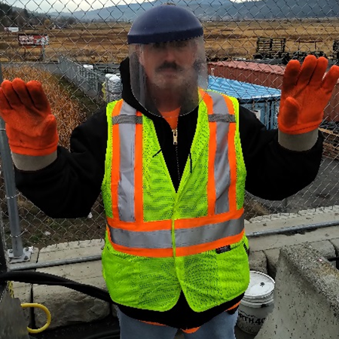

Put on appropriate PPE. (Face shield, rubber gloves and high visibility clothing) PPE is always to be worn while filling a propane tank.

Step 2
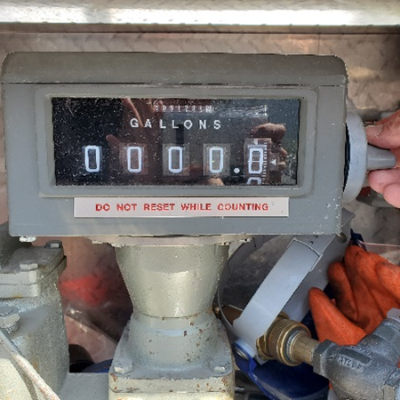
Reset gallon meter on main propane tank to 0.

Step 3
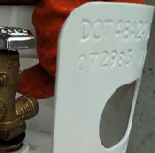
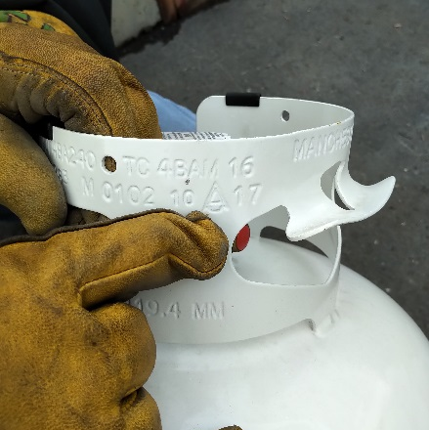

Check the date on the propane tank. Do not fill any tanks with a date older than 10 years. Follow the Standard Operating Procedure for Propane Cylinder Qualifications to properly identify the date on a tank. All tanks must be stamped with DOT (Department of Transportation).

Step 4
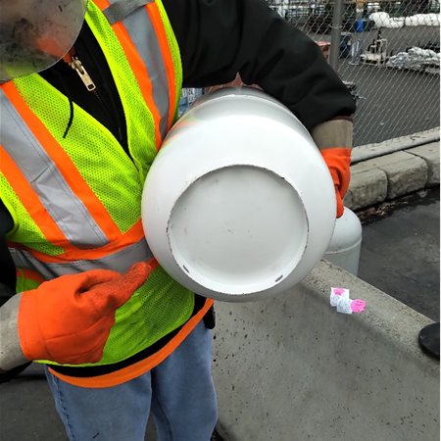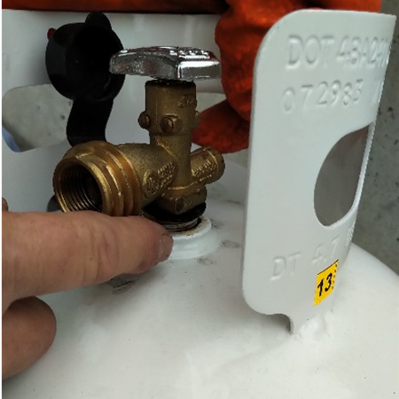
In accordance with 49 CFR § 173.301(a)(2), cylinders must undergo a visual inspection prior to being filled. If any of the defects noted in items 1 through 4 below are present, the cylinder must not be filled and may only be repaired, requalified, or rebuilt by an authorized U.S. DOT facility (see authorized RIN and VIN holders below):
- Damage to the cylinder’s exterior including dents; bulges; cuts; or cracks on the cylinder’s surface, or
to welds; and any evidence of physical abuse; fire; or heat damage.
- Detrimental rust, corrosion, or pitting on the cylinder, particularly on the bottom.
- Absence of/damage to a cylinder foot ring, cylinder neck ring (collar), or valve cover.
- A leaking or defective valve or leaking or defective pressure relief device. The face seal must be in good condition free from double sealing, gouging/tearing, roping or cracking.
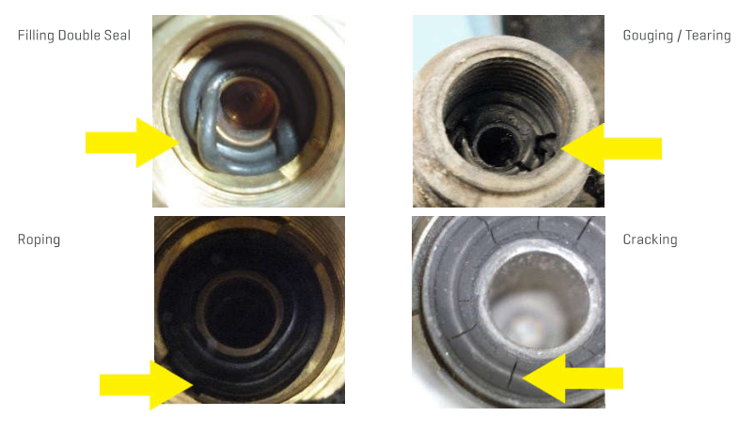

Step 5
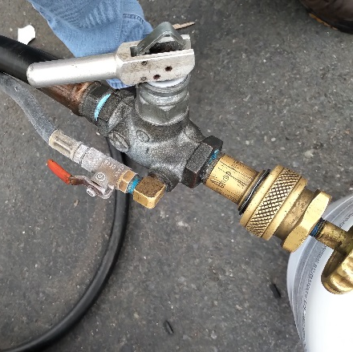
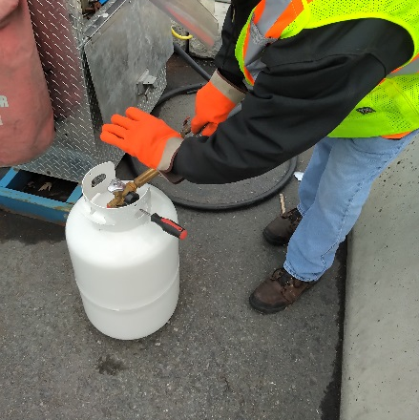

Place tank on flat ground and Insert propane hose thread (counter clockwise) into propane tank valve.

Step 6
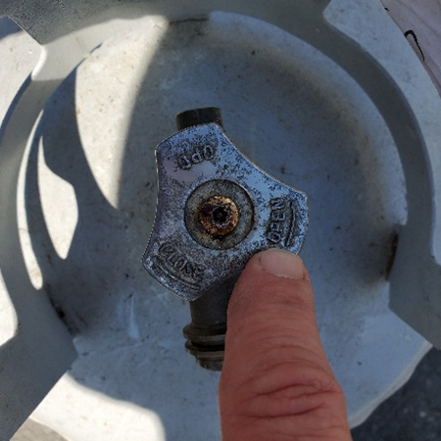
Open main valve on the propane tank that is being filled.

Step 7
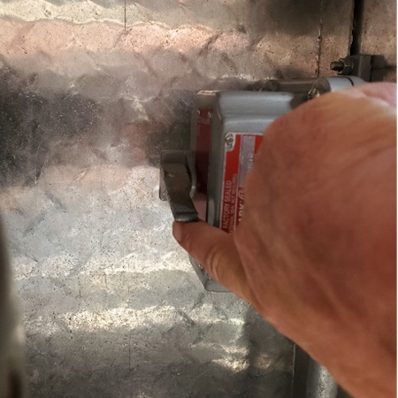
Turn unit on.

Step 8
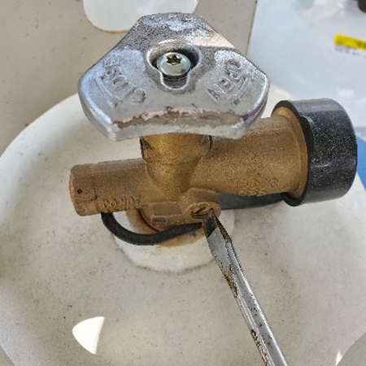
Use screw driver to open pressure relief valve on the tank being filled.

Step 9
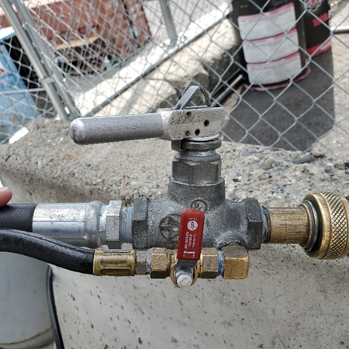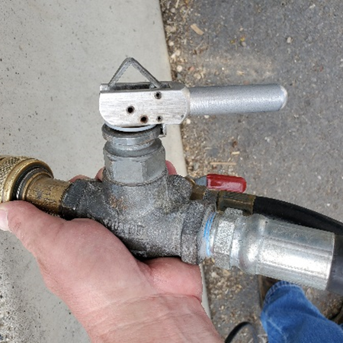
Make sure pressure relief valve is in closed position and then open valve on hose to start filling the tank.

Step 10
Make sure the gallon meter is moving and the tank is being filled with propane. (When the tank is full a steady stream of propane will emit from the pressure relief valve on the tank).

Step 11
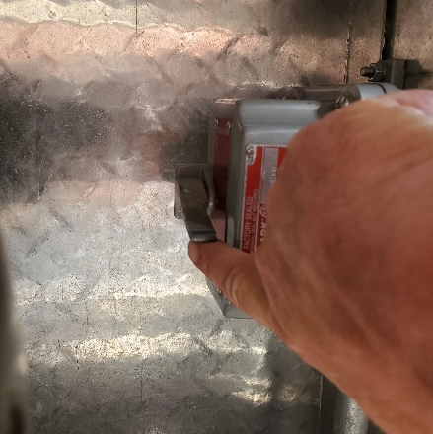

Close pressure relief valve on the tank, shut valve on hose, close valve on tank and turn off main tank switch.

Step 12
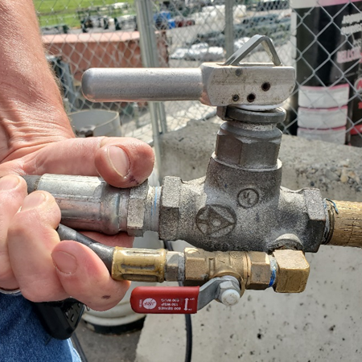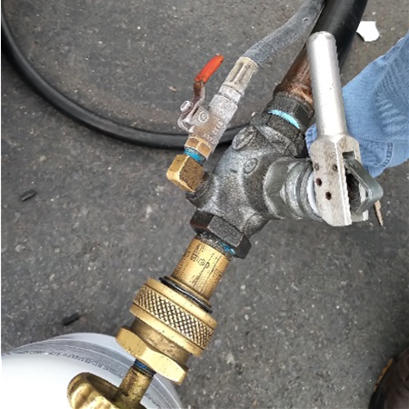
Release pressure from hose by opening valve, then disconnect hose from tank (clockwise). Note how many gallons used and let the cashiers know. Put away hose and PPE and close door.

