August 2024

Hello RETRO Members
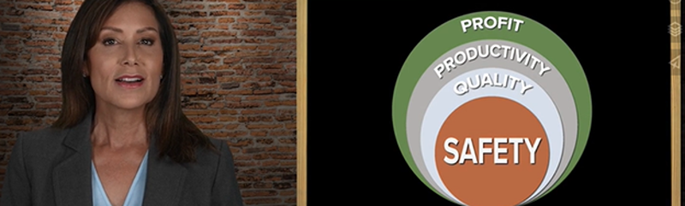
Safety Mindset Matters: Intentionally generates results!

Expect these results through intentionality Series 5 of 7

The safety packet in July introduced the “Knowledge” dimension of a resilient safety system. This month, we’re excited to share how building safety systems can lead to a culture that furthers the quality of life for your employees and management. Some of the expected positive results are:

- Well-attended safety meetings
- Management is open and approachable to employees after safety concerns.
- Consistent risk perceptions by all employees.
- Reward employees who go beyond safety compliance.
- Employees take personal ownership of the organization’s safety.
- Safety is the epicenter to drive quality, productivity, and profit.

When management is in the habit of creating systems to ensure quality safety practices, they will lead the team and create a safer work environment.

Watch this 2-minute video.

De-escalation Techniques.

WAC F417-140-000 WORKPLACE VIOLENCE. As summer temperatures rise, tempers often do as well. Difficult customers can become belligerent or even hostile. The skills to de-escalate angry or intoxicated individuals are crucial to keeping public-facing workers and customers safe. Using role-playing exercises in safety training to address different scenarios is a practical way to acclimate employees on how to de-escalate these types of events.

For more tips on how to deal with potential violence, visit our Violence page in the RS Safety Library.

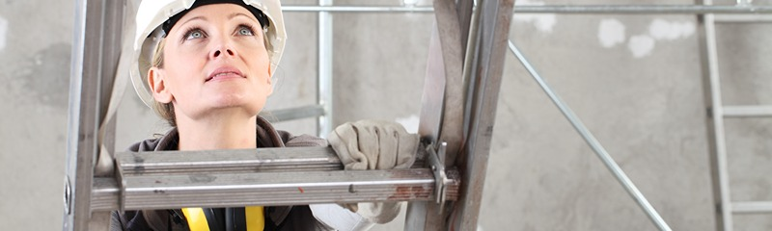
Ladder Use

WAC F417-268-000 LADDER SAFETY GUIDE. Falling from ladders is one of the most common causes of fall-related fatalities, according to the National Safety Council’s statistics. In any given year, approximately 65,000 individuals receive emergency room treatment due to ladder accidents. Most ladder-related incidents happen ten feet or less from the ground. Remember, always choose the most appropriate ladder for the project.

More information is available on RS SafetyTV
or the RS Safety Library. The SAFEME app has a module on Ladders and is a great refresher course!

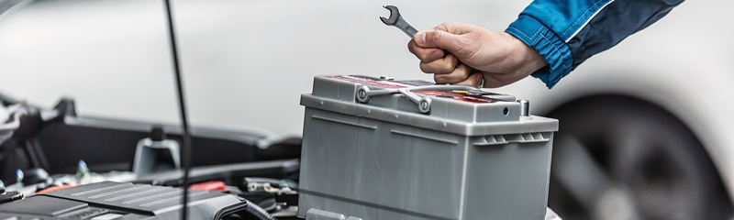

Battery Safety

Batteries contain sulfuric acid and can produce explosive mixtures of hydrogen and oxygen. Even when the battery is not operating, the self-discharge action generates hydrogen gas, so make sure batteries are stored and worked on in a well-ventilated area.

Some of the hazards that can happen when working with batteries are:
- Chemical burns from the sulfuric acid.
- Electrical shocks or burns.
- Explosions from a spark igniting the hydrogen/oxygen gases.
- Lifting injuries.

Safety tips for working with batteries:
- Always wear ANSI Z87.1 approved safety glasses and face shield or splash-proof goggles when working on or near batteries.
- Always wear proper hand protection.
- Keep all sparks, flames, and cigarettes away from the battery.
- Never try to open a battery with non-removable vents.
- Keep removable vents tight and level except when servicing electrolytes.
- Make sure the work area is well ventilated.
- Never lean over a battery while boosting, testing, or charging.
- Exercise caution when working with metallic tools or conductors to prevent short circuits and sparks. If you are wearing jewelry, you should remove it while working with batteries.

Batteries are heavy, considering their size, so exercise care and proper body mechanics when lifting them. If possible, store batteries at waist height to reduce the need to bend over to move them. A smart method of transporting them is with a cart or hand truck rather than hand-carrying them. It’s highly recommended keep a battery spill kit on hand.

More on this subject can be found in the Auto section in the RS Safety Library.

Think safe. Act safe. Be safe.

Rose Gundersen Johnathan Kirby
VP of Operations & Retail Services Safety Coordinator
360-200-6452 360-646-9418
rgundersen@waretailservices.com jkirby@waretailservices.com

