September 2024
Dear RETRO Members:


Safety Compliance Made Easy Webinar

With Travis Brock, our new Safety Director who brings over 20 years of safety professional experience. His deep knowledge and personable approach have contributed to his success across various industries.

Date/Time: September 12th (Thurs) 10:00-11:00AM PDT

Washington alone accounts for over 7.5% of safety inspections nationwide.

REGISTER HERE

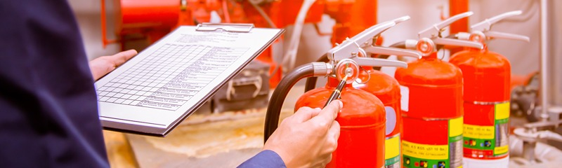
Fire Safety – With Fall approaching, it’s a good time to review fire safety by checking fire alarms and smoke detectors, looking over the heating systems and electrical equipment for proper functionality.
- How are those fire extinguishers holding up? WAC 296-800-300
  - Annual Inspection of the extinguishers
  - Monthly check off the extinguishers
- Do your employees know how to operate a fire extinguisher? (PASS, Pull, Aim, Squeeze, Sweep)
  - Have your employees been trained?
- Are emergency exit doors free from blockage and operating correctly?
- When did you last perform a fire drill exercise? WAC 212-12-044

Assume that if a fire were to happen, are all the things in place for everyone to safely exit? Here is a great link for more fire safety tips.

Fire Safety Resources

Governors Safety and Health Conference September 25-26
Greater Tacoma Convention Center 1500 Commerce St Tacoma, WA 98402
The annual Governor’s Industrial Safety and Health Conference is your go-to event for cutting-edge tools, technologies, and strategies in workplace safety and health. The Exhibit Hall will showcase the latest products and services from top vendors. Additionally, immersive full-day pre-conference training sessions will be available to deepen your expertise.
During the Conference they will recognize an exhibitor with the Lifesaving Award. The conference draws over 1000 attendees dedicated to enhancing workplace safety and health..
Registration: Exhibitors Attendees


Bad vibes are a safety hazard.
A toxic work environment can insert “bad vibes” that could significantly undermine safety in a variety of ways. Please discuss these with your team and consider ways the whole team could be part of the solution.
Reduced Focus and Morale: Low morale and disengagement can lead to negligence in following safety procedures, increasing accident risk.
Poor Communication: Negative atmospheres can cause communication breakdowns, preventing employees from reporting hazards or near-misses.
Increased Stress: Chronic stress from a hostile work environment impairs decision-making and heightens the risk of unsafe practices.
Weak Teamwork: Poor workplace culture can erode team cohesion, reducing effective collaboration on safety protocols.
Resistance to Change: Employees may resist safety improvements if they lack trust in leadership due to a negative environment.
Solutions from management to the team:
- Promote Positivity: Build a supportive culture and recognize employee contributions.
- Encourage Reporting: Ensure safe channels for reporting hazards.
- Support Well-being: Provide resources to manage stress.
- Invest in Training: Regular training and team building improve safety compliance.
- Lead by Example: Demonstrate commitment to safety from the top.
Improving workplace culture is crucial for enhancing safety and overall productivity.

Think safe. Act safe. Be safe.
Travis Brock Johnathan Kirby
Director of Safety Safety Coordinator
206-617-6191 360-646-9418
tbrock@waretailservices.com jkirby@waretailservices.com

