December 2024

Hello RETRO Members,

**Safety Mindset Matters: Share your Accident Prevention Program experience**

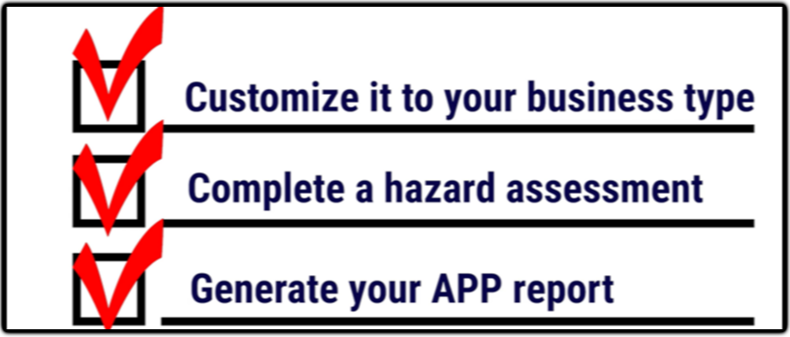

A safety mindset goes beyond just following rules or checking boxes; it’s about identifying and addressing risks proactively before incidents occur. Businesses should set the standard by demonstrating that safety isn’t just a priority, but a core value.

This month, we want to focus on your [Accident Prevention Program (APP)](https://www.lni.wa.gov/safety-health/preventing-injuries-illnesses/create-a-safety-program/accident-prevention-program) to help your business become a safety-conscious organization. A current APP provides a structured approach to recognizing, managing, and preventing workplace hazards. All employers are required by the Labor and Industries (LNI) to have a current APP and this is one of the most cited items during safety audits!

Help us better understand how your business approaches workplace safety by completing a 1-minute survey on your experience with APP. Click the link [HERE](https://www.surveymonkey.com/r/Y5LTHB9) to get started!

**Highlighting sober driving in the month of December.**

Happy December! It’s a timely reminder to focus on the importance of safe driving, particularly during the Holiday Season. Impaired driving continues to be a significant issue for delivery drivers and off-hour driving. The statistics for Washington State, especially with alcohol 52.6% and THC 10.3% ([[DATA FROM WASHINGTON TRAFFIC SAFETY COMMISSION](https://wtsc.wa.gov/traffic-safety-reports/#soberdrivingreports)](https://wtsc.wa.gov/traffic-safety-reports/#soberdrivingreports)) involvement in fatalities, highlight the ongoing dangers of impaired driving and the need for vigilance both on the road and within the workplace.

It’s crucial for employers to take this opportunity to review and update workplace policies related to substance abuse. This includes addressing not only the consequences of impaired driving but also the potential impact it has on employees’ safety, productivity, and overall well-being. Ensuring employees understand the importance of maintaining a clear and focused mind at work and while driving can help reduce risk across the board.

If you’re able to update policies, here are a few things to consider:

* Clear guidelines on substance use, impairment at work and while commuting.
* Support programs for employees dealing with substance abuse issues (such as EAPs—Employee Assistance Programs).
* Training and awareness program for employees to understand the risks of impairment and the company’s stance on safety.
* Testing and enforcement measures, if appropriate, to deter impaired driving.

These steps can help create a safer, more productive work environment and contribute to safer roads for everyone.

**How poor posture and awkward positions can damage your back for life.**

Poor posture and awkward body positions can lead to discomfort, injury, and reduced productivity. When performing tasks that force the body out of its natural "neutral" alignment, muscles must work harder, which increases the risk of strain and fatigue.

Awkward postures often occur during activities such as twisting the neck, bending the head downward, or reaching, lifting, or pulling objects in a way that puts stress on the body.

To help prevent awkward postures and reduce the risk of injury:

* Keep frequently used items within easy reach to avoid unnecessary stretching or bending.
* Aim to maintain a neutral body posture as much as possible.
* Avoid twisting or bending motions whenever you can.
* Use both hands when lifting or handling objects to distribute the effort.
* Change your posture or switch tasks regularly to avoid staying in one position for too long.
* Take breaks to stand up, walk, and stretch to reduce muscle fatigue.
* Ensure that you are engaging your legs when lifting heavy items.

For more guidance on ergonomic principles, please visit our [Safety Library](https://waretailservices.com/safety/ergonomics/).



**How the proper use of pallet jacks can save your health and time.**

Using a pallet jack correctly can significantly improve both safety and productivity. Pushing a pallet jack is generally safer and more efficient than pulling, for several reasons:

* Pushing allows you to have better control over steering and maneuvering the load, and it gives you the ability to stop more quickly.
* Pushing enables you to move up to four times more weight compared to pulling.
* It’s harder to stop a load quickly when pulling, which can increase the risk of accidents or collisions with the load or other objects.
* Pulling a pallet jack can put your body in an awkward position, especially for your lower back, which may lead to strain or injury over time.

When used properly the pallet jack can be an excellent tool to assist you and your workers, not only put less emphasis on your body and health but boost productivity while remaining safe.

**Always - *Think safe. Act safe. Be safe.***

**Travis Brock Johnathan Kirby**

**Director of Safety Safety Coordinator**

**206-617-6191 360-646-9418**

[**tbrock@waretailservices.com**](mailto:tbrock@waretailservices.com)[**jkirby@waretailservices.com**](mailto:jkirby@waretailservices.com)