March 2025

Hello RETRO Members.

**Safety Mindset Matters: Invite employee input on PPE can save lives.**

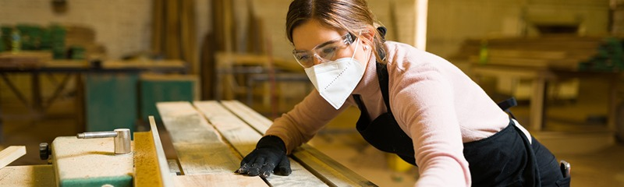

**Making PPE gear personal will increase usage**

[**WAC 296-800-160**](https://app.leg.wa.gov/wac/default.aspx?cite=296-800-160)

In celebration of International Women’s Month this March, management must ensure that personal protective equipment (PPE) fits diverse body sizes rather than relying solely on gender-neutral designs. Ill-fitting or uncomfortable PPE can discourage proper use and compromise worker safety. Engaging employees in the selection process significantly increases the likelihood that these vital protective items will be consistently used.

Common types of PPE include:

* **Gloves**: Essential for protecting hands from cuts or exposure to chemicals.
* **Ear Protection**: Choose earplugs or earmuffs based on comfort and the noise level of the environment.
* **Eye Protection**: Workers must wear goggles, glasses, or face shields when working with chemicals, power tools, or cutting materials to prevent eye injuries.
* **Safety Boots**: Boots with metal toecaps protect workers from heavy objects or moving equipment.
* **Respirators**: Necessary when dust, fumes, or vapors are present to protect the nose and throat.

When management takes the time to encourage selecting the appropriate PPE for employees, the caring attitude speaks loudly about the importance of prioritizing their safety.

For additional PPE resources, explore:

* [RS Safety Library](https://waretailservices.com/safety/safety-library-table-of-contents/)
* [RS SafetyTV (PPE topic)](https://www.youtube.com/watch?v=zQiDkue4Rz8&list=PL-_I4binSRgmPgw9gdhFpENnveEFYvOAd)
* [SAFEME’s PPE lesson](https://wrasafeme.org/)

**Eye Injuries: Common but Preventable**

[**WAC 296-155-215**](https://app.leg.wa.gov/wac/default.aspx?cite=296-155-215)

Eye injuries are one of the most frequent workplace injuries, yet they are also among the easiest to prevent. According to the most recent data from [Bureau of Labor & Statistics](https://www.bls.gov/opub/ted/2023/workers-suffered-18510-eye-related-injuries-and-illnesses-in-2020.htm):

* **Eye hazards are prevalent across many industries** – The retail sector alone represents 17% of all industrial eye injuries.
* **A leading cause of lost work hours** – Eye injuries contribute to 37% of all head injuries off and 62% of all face injuries that cause work time loss.
* **Main causes of eye injuries** – Nearly 50% of the incidents studied were due to objects do not use hands around the face or eyes after without handwashing is a good prevention measure. striking or scratching the eye, while chemical exposure caused 10% of eye injuries.

To learn more about eye safety, check out the following resources:

* [Eye safety videos on RS Safety TV](https://youtu.be/zQiDkue4Rz8)
* [Eyewash lesson on SAFEME](https://wrasafeme.org/)
* [L&I Safety Meeting Kit for Personal Eye Protection Gear](https://www.lni.wa.gov/safety-health/safety-training-materials/training-kits)

**Safe Ladder Use Saves Lives**

[**296-876 WAC**](https://app.leg.wa.gov/wac/default.aspx?cite=296-876)

Ladder falls are a leading cause of workplace fatalities. In the most recent study by National Safety Council reported 645 deaths and 49,250 injuries from ladder falls.

Most accidents occur while descending or from heights of ten feet or less, making it crucial to always use the right ladder for the job.

To prevent injuries, follow these key safety tips:

* Use the appropriate ladder for each task
* Inspect ladders for damage
* Ensure stability and maintain three points of contact

For more ladder safety information, check out:

* [RS SafetyTV](https://www.youtube.com/@RASISAFETYTV)
* [RS Safety Library](https://waretailservices.com/safety/safety-library-table-of-contents/)
* [SAFEME’s Ladders module](https://wrasafeme.org/)



**Dangers of Slips, Trips, and Falls in the Workplace**

[**WAC 296-24-73505**](https://app.leg.wa.gov/wac/default.aspx?cite=296-24-73505)

Slips, trips, and falls are among the most common and dangerous workplace accidents, often leading to serious injuries like fractures, sprains, or head trauma. These accidents can occur due to wet or oily surfaces, obstacles, or uneven flooring.

How to Prevent Slips, Trips, and Falls:

* **Clear Walkways**: Regularly remove ice and snow from pathways and entrances, using salt or sand to improve traction.
* **Proper Footwear**: Ensure employees wear slip-resistant shoes, especially in icy conditions.
* **Signage & Lighting**: Place clear warning signs and improve lighting to help workers spot hazards, especially in the dark winter months.
* **Training & Awareness**: Educate employees on how to recognize and avoid hazardous conditions and encourage careful walking in slippery areas.

By addressing the risks of slips, trips, and falls, especially during icy conditions, employers can protect their workforce from serious injury and reduce costly accidents.

Helping you with safety,

**Travis Brock** **Johnathan Kirby**

**Director of Safety** **Safety Coordinator**

**206-617-6191** **360-646-9418**

[tbrock@waretailservices.com](mailto:tbrock@waretailservices.com) [jkirby@waretailservices.com](mailto:jkirby@waretailservices.com)